Experiment 6

**Aim**

Study and Implement of Storage as a Service (STaaS)

**Theory**

1. Prepare a detailed study of Storage as a Service (STaaS)

Ans: Storage as a Service or STaaS is cloud storage that you rent from a Cloud Service Provider (CSP) and that provides basic ways to access that storage. Enterprises, small and medium businesses, home offices, and individuals can use the cloud for multimedia storage, data repositories, data backup and recovery, and disaster recovery. There are also higher-tier managed services that build on top of STaaS, such as Database as a Service, in which you can write data into tables that are hosted through CSP resources.

The storage you choose will typically depend on how often you intend to access the data. Cold data storage is data that you leave alone or access infrequently, whereas warm or hot data is accessed regularly and repeatedly. Pricing by quantity tends to be more cost efficient but isn’t intended to support fast and frequent access for day-to-day business productivity. For hot or warm data, an SLA will be crucial to leveraging data storage in support of current projects or ongoing processes.

Many CSPs make it easy to onboard and upload data into their STaaS infrastructure for little to no cost at all. However, there may be hidden fees and it can be extremely costly to migrate or transfer your data to a different cloud platform.

1. Advantages and Limitation of STaaS for S3 & S3 Glacier service

Ans: **Advantages of STaaS**

Key advantages to STaaS in the enterprise include the following:

**Storage costs.** Personnel, hardware and physical storage space expenses are reduced.

* **Disaster recovery.** Having multiple copies of data stored in different locations can better enable disaster recovery measures.
* **Scalability.** With most public cloud services, users only pay for the resources that they use.
* **Syncing.** Files can be automatically synced across multiple devices.
* **Security.** Security can be both an advantage and a disadvantage, as security methods may change per vendor. Data tends to be encrypted during transmission and while at rest.

**Disadvantages of STaaS**

Common disadvantages of STaaS include the following:

* **Security.** Users may end up transferring business-sensitive or mission-critical data to the cloud, which makes it important to choose a service provider that's reliable.
* **Potential storage costs.** If bandwidth limitations are exceeded, these could be expensive.
* **Potential downtimes.** Vendors may go through periods of downtime where the service is not available, which can be trouble for mission-critical data.
* **Limited customization.** Since the [cloud infrastructure](https://www.techtarget.com/searchcloudcomputing/definition/cloud-infrastructure) is owned and managed by the service provider, it is less customizable.
* **Potential for vendor lock-in.** It may be difficult to migrate from one service to another.

**Activity**

1. With the help of any suitable cloud service (S3 & S3 Glacier Service) Perform  STaaS
2. Use of S3 & S3 Glacier service in AWS (STaaS)

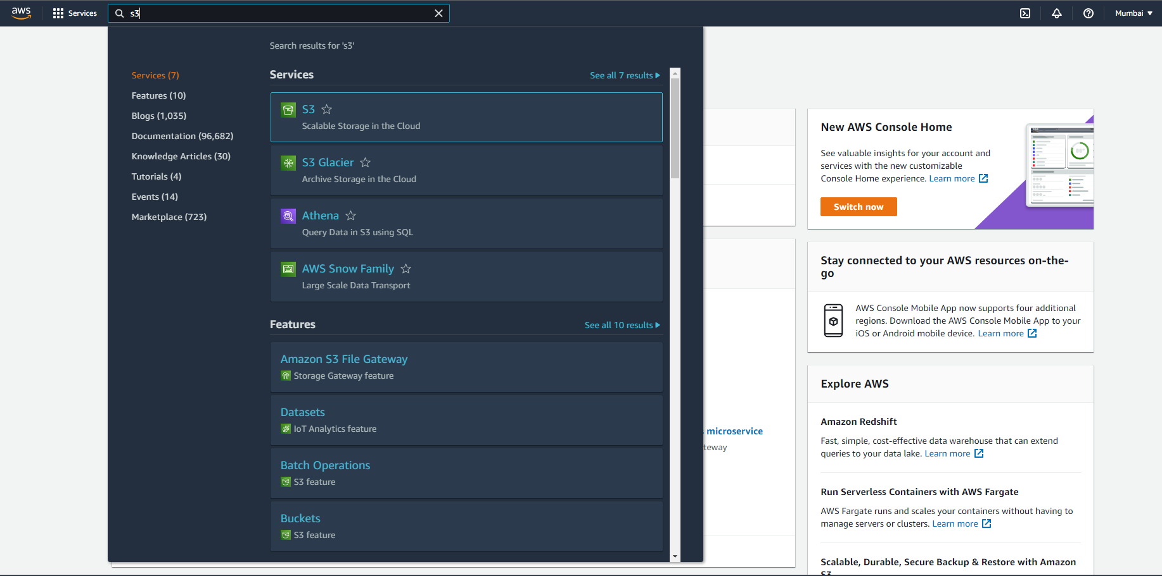

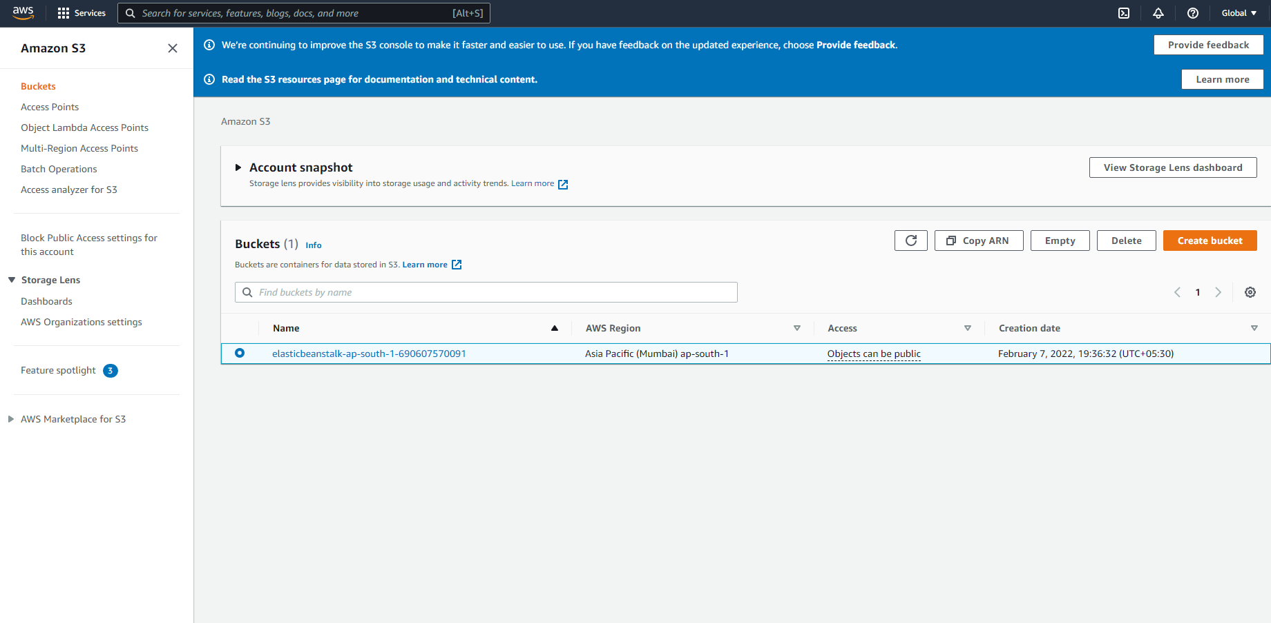

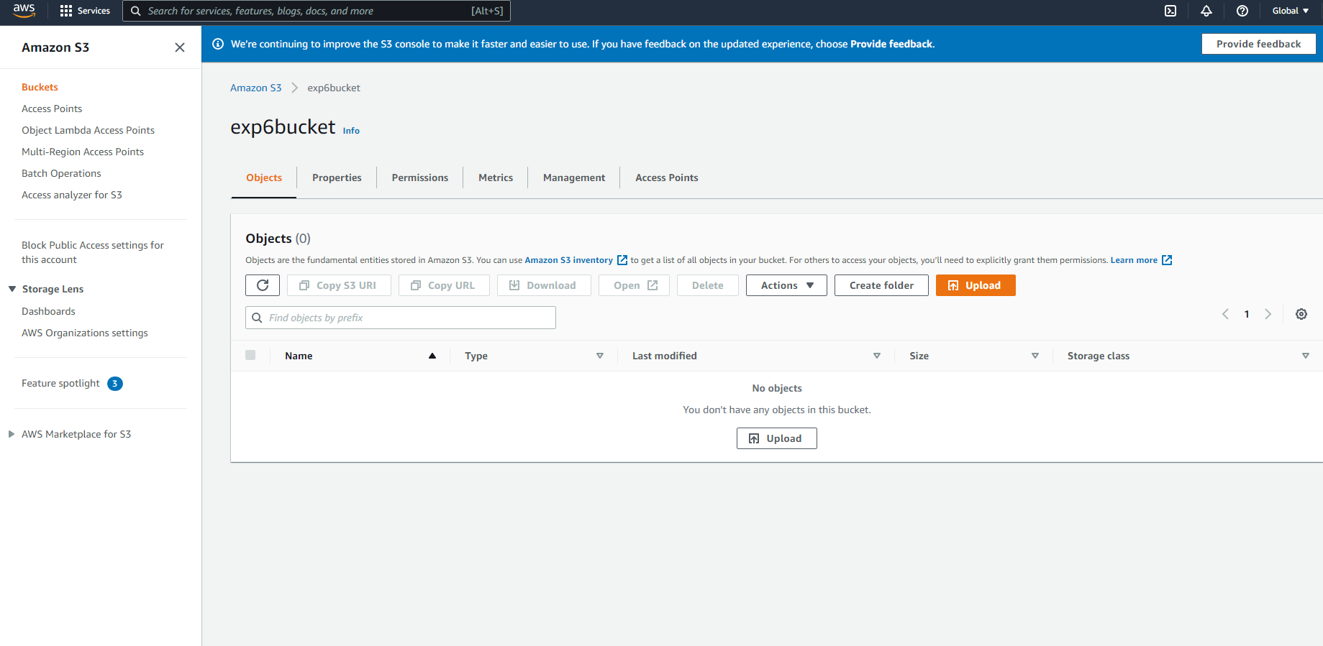

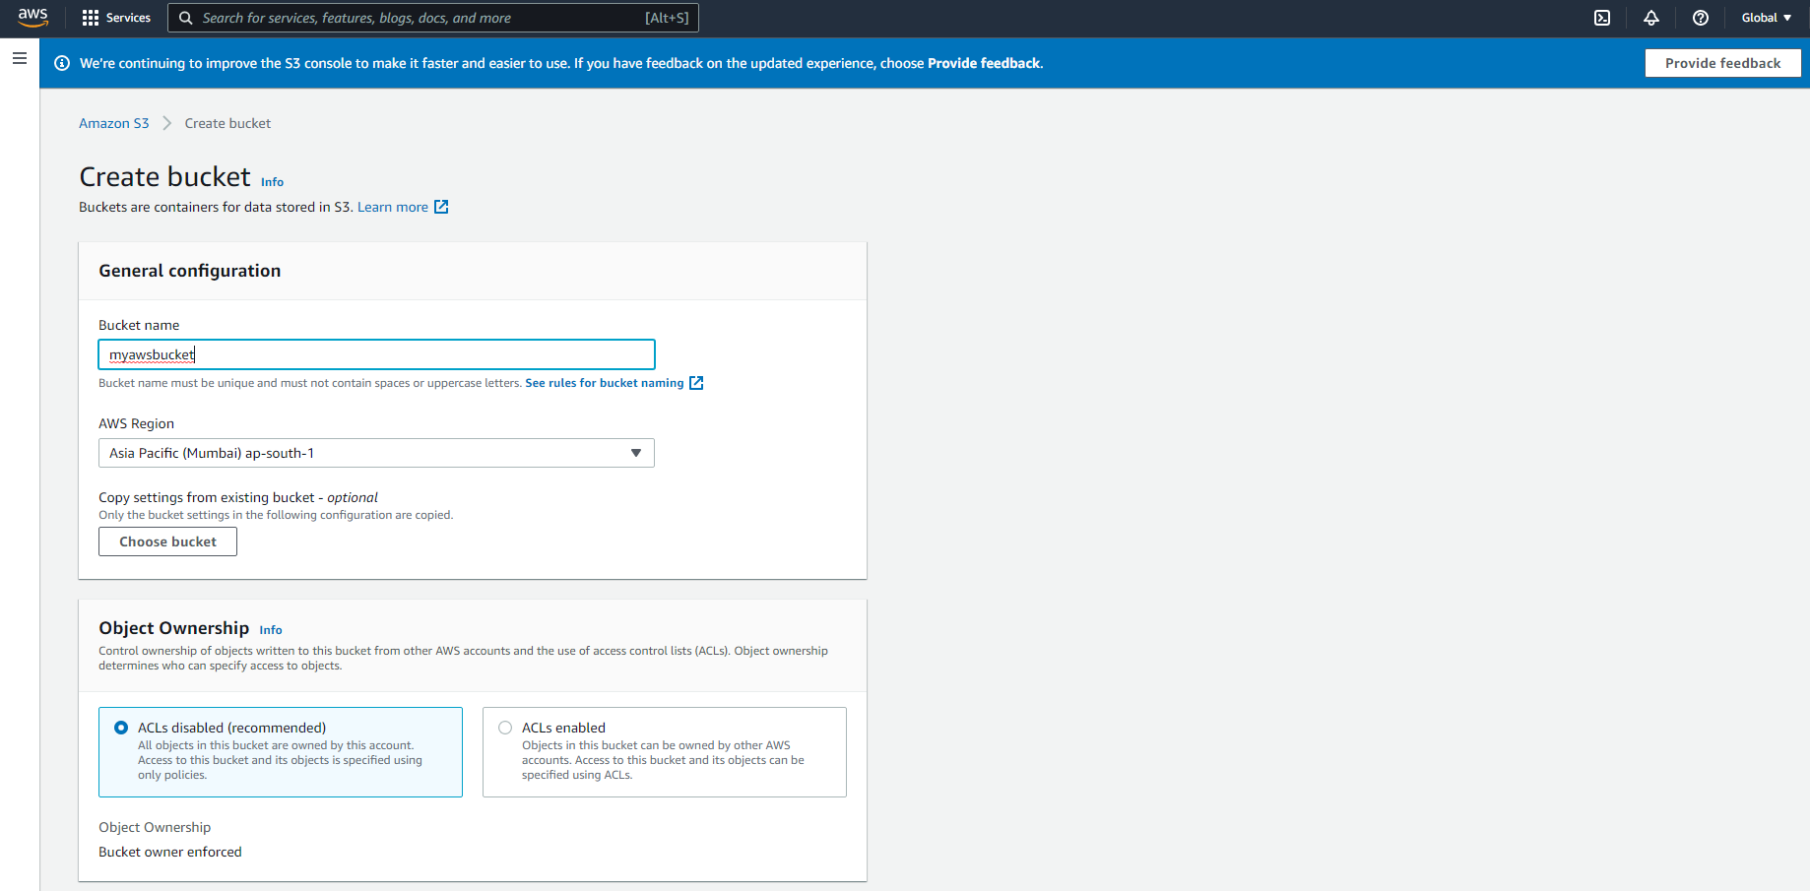

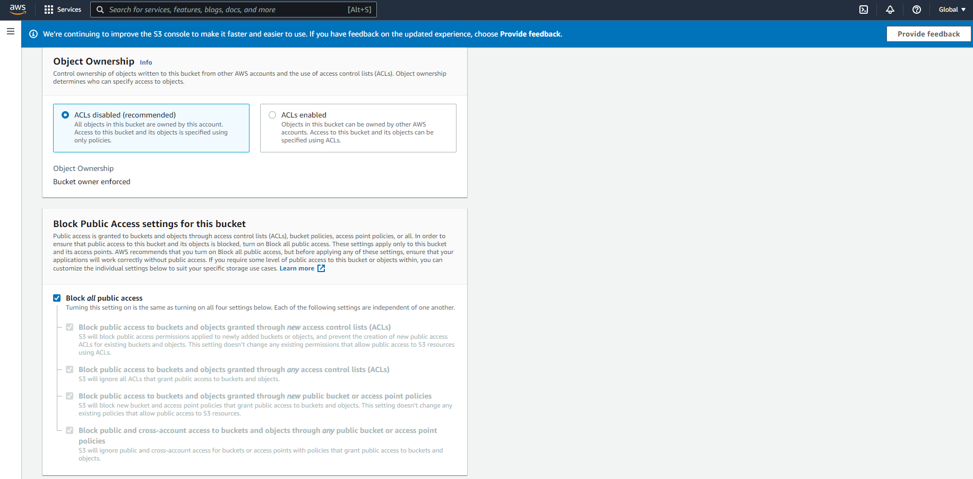

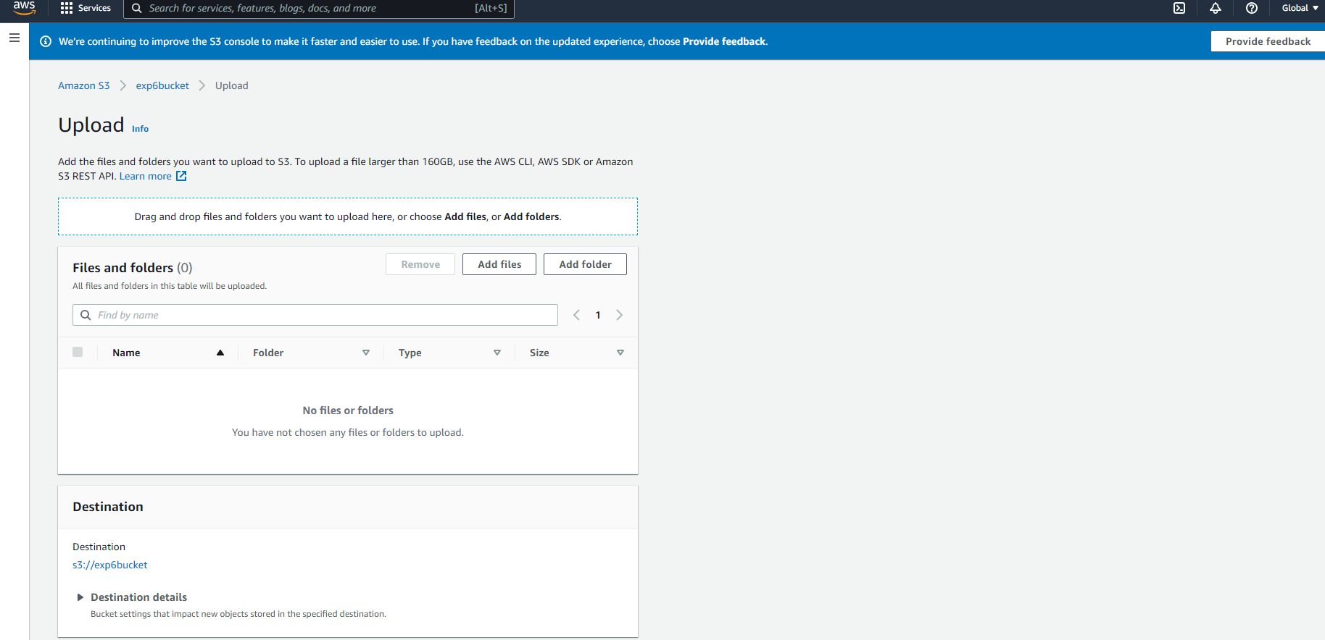

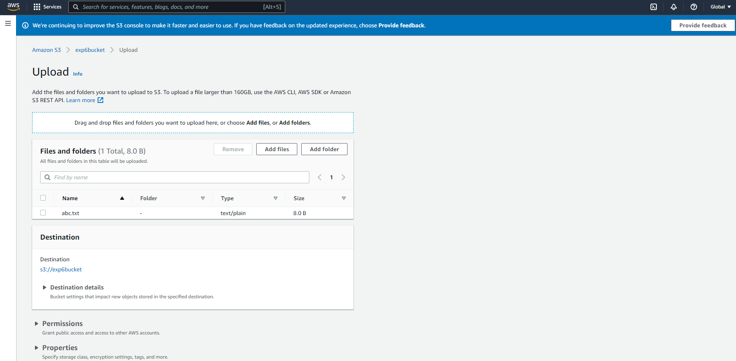

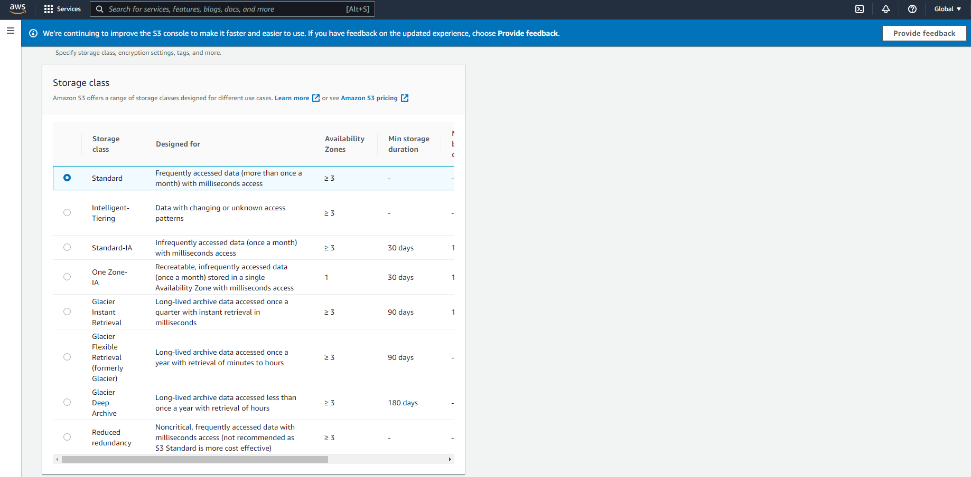

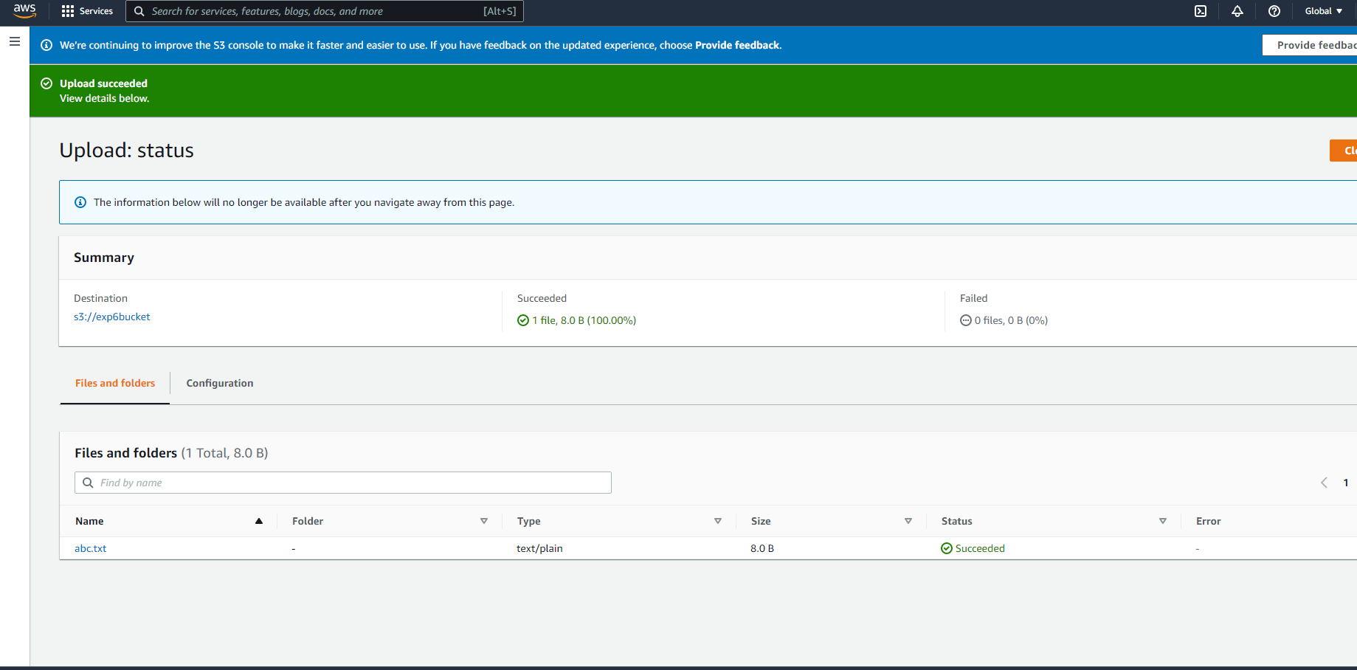

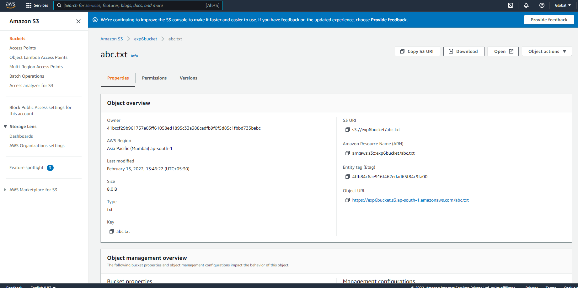

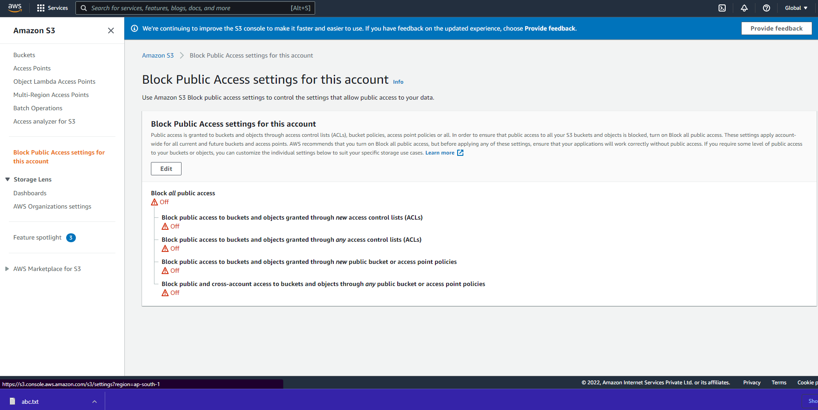

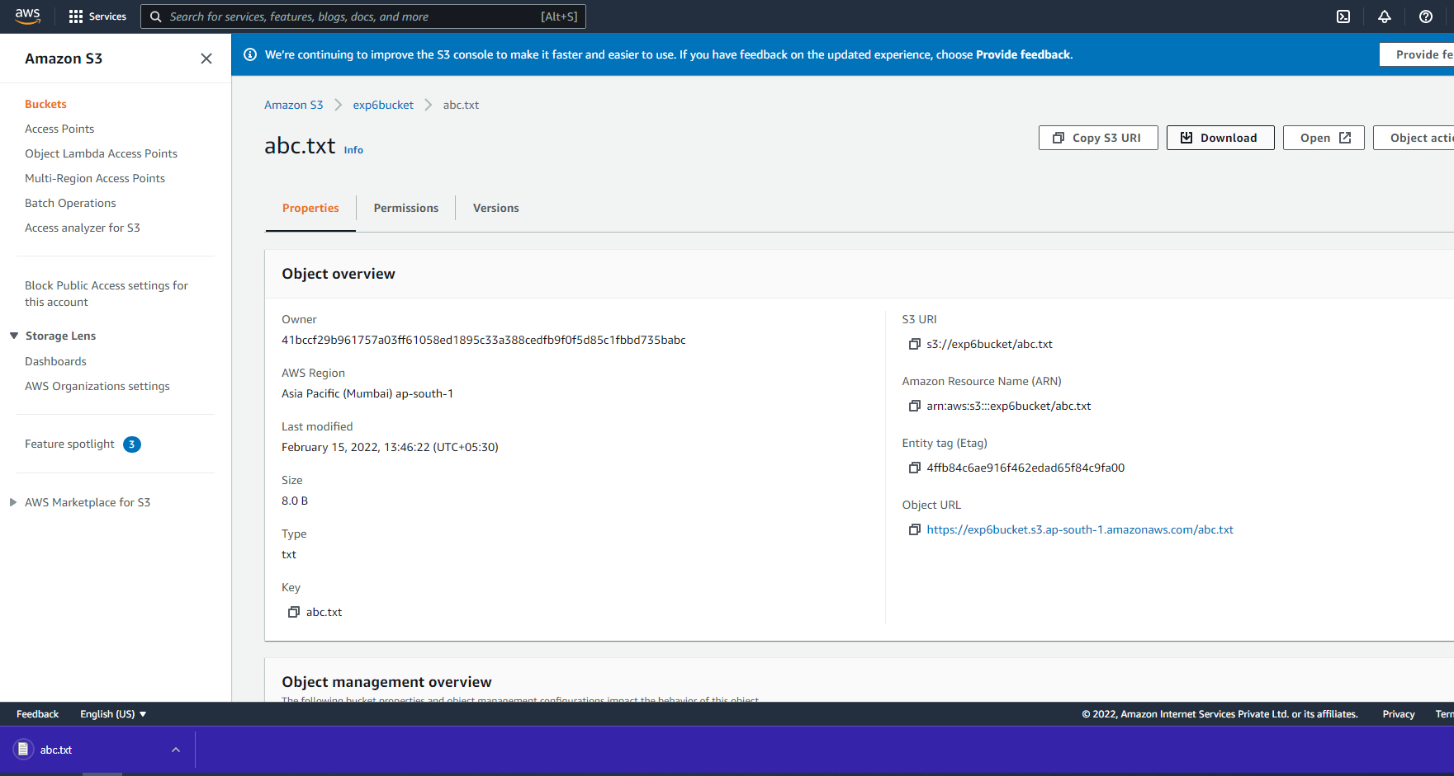

**Conclusion**

Demonstrate the CRUD operations on different SQL and NoSQL databases running on cloud

Ans:

**SQL databases - MySQL databases:**

**CREATE -**

CREATE TABLE *table_name* (

*column1 datatype*,

*column2 datatype*,

);

**READ -**

CREATE VIEW *view_name* AS

SELECT *column1*, *column2*, ...

FROM *table_name*

WHERE *condition*;

**UPDATE -**

UPDATE *table_name*

SET *column1* = *value1*, *column2* = *value2*, ...

WHERE *condition*;

**DELETE -**

DELETE FROM *table_name*

WHERE *condition*;

**NoSQL databases - MongoDB:**

**CREATE -**

{

create: <collection or view name>,

capped: <true|false>,

timeseries: {

timeField: <string>,

metaField: <string>,

granularity: <string>

},

expireAfterSeconds: <number>,

autoIndexId: <true|false>,

size: <max_size>,

max: <max_documents>,

storageEngine: <document>,

validator: <document>,

validationLevel: <string>,

validationAction: <string>,

indexOptionDefaults: <document>,

viewOn: <source>,

pipeline: <pipeline>,

collation: <document>,

writeConcern: <document>,

comment: <any>

}

**READ -**

Use the db.createCollection() method or the create command:

db.createCollection(

"<viewName>",

{

"viewOn" : "<source>",

"pipeline" : [<pipeline>],

"collation" : { <collation> }

}

)

Use the [db.createView()](https://docs.mongodb.com/manual/reference/method/db.createView/#mongodb-method-db.createView) method:

db.createView(

"<viewName>",

"<source>",

[<pipeline>],

{

"collation" : { <collation> }

}

)

**UPDATE -**

db.collection.update(query, update, options)

**DELETE -**

db.collection.remove(

<query>,

{

justOne: <boolean>,

writeConcern: <document>,

collation: <document>,

let: <document> // Added in MongoDB 5.0

}

)

**REFERENCES**

1. <https://www.intel.com/content/www/us/en/cloud-computing/storage-as-a-service.html>
2. <https://www.techtarget.com/searchstorage/definition/Storage-as-a-Service-SaaS>